Online Gym Management System

1. Introduction 3

2. Functional Requirements 4

2.1 Customer Module 5

2.2 Trainer Module 11

2.3 Manager Module 16

**2.4** Admin Module 22

**2.5**  Use Case Diagram.............................................................................................................................26

THIS DOCUMENT CONTAINS 29 NUMBERED PAGES

# Introduction

This document explains the system requirements and scope for developing Online Gym Management System.

Online Gym Management System could divide the four main parts, Customer part, Trainer part, Manager part, Admin part.

This document describes the system requirements.

# Functional Requirements

The Account part of Online Gym Management System has four modules which are divided 13 processes described as below.

|  |  |  |
| --- | --- | --- |
| **No** | **BRS requirement ID** | **Description** |
| **2.1** | **Customer Module** | |
| **2.1.1** | **F1** | **Account Creation Process** |
| **2.1.2** | **F2** | **Login Process** |
| **2.1.3** | **F3** | **Forgot Password Process** |
| **2.1.4** | **F4** | **Change Password Process** |
| **2.1.5** | **F5** | **Update Account Process** |
| **2.1.6** | **F6** | **Search Plan Process** |
| **2.1.7** | **F7** | **Select plan Process** |
| **2.1.8** | **F8** | **Browse Profile process** |
| **2.1.9** | **F9** | **Give Feedback Process** |
|  |  | |
| **2.2** | **Trainer Module** | |
| **2.2.1** | **F10** | **Account Creation Process** |
| **2.2.2** | **F11** | **Login Process** |
| **2.2.3** | **F12** | **Forgot Password Process** |
| **2.2.4** | **F13** | **Change Password Process** |
| **2.2.5** | **F14** | **Update Account Process** |
| **2.2.6** | **F15** | **Browse Profile Process** |
| **2.2.6** | **F16** | **Prepare diet Plan Process** |
|  |  |  |
| **2.3 Manager Module** | | |
| **2.3.1** | **F21** | **Login Process** |
| **2.3.2** | **F22** | **Forgot Password Process** |
| **2.3.3** | **F23** | **Change Password Process** |
| **2.3.4** | **F24** | **Update Account Process** |
| **2.3.5** | **F25** | **Prepare schedule** |
| **2.3.5** | **F26** | **Trainer Allocation** |
| **2.3.6** | **F27** | **Equipment Management** |
|  |  |  |
| **2.4 Admin Module** | | |
| **2.3.1** | **F21** | **Login Process** |
| **2.3.2** | **F22** | **Forgot Password Process** |
| **2.3.3** | **F23** | **Change Password Process** |
| **2.3.4** | **F24** | **Update Account Process** |
| **2.3.5** | **F25** | **Browse All Profile** |
| **2.3.6** | **F26** | **Report Generation**   |  |  |  | | --- | --- | --- | | **2.3.6** | **F26** | **Report Generation** | |

## Customer Module

* Customer can register by using their personal details.
* Registered customers are supposed to log in to the system with their credentials.
* Registered customers can manage their workout schedule (checking availability).
* Registered customers can check their diet.
* Registered customers can check their day wise sets.
* Registered customers can see their starting weight, measures and goals.
* Registered customer can give feedback.

### Account Creation Process

* Online Gym Management System compels to create the account before using it. So, Online Gym Management System should provide the function which makes customer creates new account.
* When Customer creates new account, the function demands four information described as below.

1. Login information
2. Contact Details

* The Login information

The Login information consists of some items described as below.

1. UserID
2. Password
3. First Name
4. Last Name
5. E-mail address
6. User Type
   * All items are compulsory demanded.
   * UserID

* The UserID should be unique. If the UserID correspond with not case-sensitive to other which is previously registered, the UserID should not be registered as an account.
  + Password
* The Password has constrains which makes the Password consists of more than or equal 8 and less than or equal 16 characteristics including characters described as below.

1. Numeric figure (at least one)
2. Capital alphabet (A-Z)(at least one)
3. Small alphabet (a-z)(at least one)
4. Special character (#, $, %, &, etc.) (at least one)

* The Password is masked by dummy characters. The re-entering Password is demanded.
* The Password must be encrypted in Online Gym Management System.
  + User Type

The User Type falls into three categories described as below.

1. Customer
2. Trainer
3. Manager
4. The User Type defines also four types of user; " Customer user"," Trainer user", and " Manager user”.

* In an Account Creation Process, the user can select Customer.
* No one could select The Admin, because Admin is implemented to Online Gym Management System in advance.
* Contact Details
* The Contact Detail consists of some items described as below.

1. Permanent Address
2. Contact Phone No
3. Emergency Contact No
   * All items are compulsory demanded.
   * Permanent Address

* Permanent Address should be filled.
* But only the state should be selected from options.
* The Security Question information

The Security Question information is needed when user lost their Password.

This information consists of two items described as below.

1. Selected Question
2. Answer
   * All items are compulsory demanded.
   * Some questions which are difficult to answer for anyone else are prepared in advance.

E.g. which color do you like most?

* + A question should be selected from options by the customer, and the Answer is registered by the customer.
* Login information should be entered on one screen, and then customer information and Security Question information should be entered on another screen.

### Login Process

* Online Gym Management System always compels user authentication before using itself except when a new account is successfully created.
* The user authentication demands UserID and Password. The UserID and the Password should be checked in three ways.
  + First, The UserID and the Password should be existed and correct.
* If The UserID and the Password are not equal to what the user has registered, the user authentication cannot be provided.
  + Second, the User Type linked to the UserID should be "Customer".
* When the User Type is " Customer ",then user can be placed on “Customer Home”.
  + Finally, UserID should be available.
* The Admin can decide whether the UserID is available or suspended – Refer to the SRS of the Admin part.
* If customer is rejected, user authentication is not provided for system user.
* The customer account should alive for so long as the duration decided by Admin.
* Only when the three checks are successfully completed, customer can be placed on respected page.
* The “Customer Home” provides the some items described as below.

1. A trigger to logout
2. A trigger to update Account
3. A trigger to Change Password
4. A trigger to Search Package
5. A trigger to Select Package
6. A trigger to Browse existing History

### Forgot Password Process

* When system user lost their Password, the recovery method should be provided by Online Gym Management System.

The recovery method is described as below.

* + First, system user enters their UserID for Online Gym Management System .
  + Next Online Gym Management System demands the Answer which has been registered since when the Account was created.
  + Only when the Answer is correct, customer get the new password by E-mail which also has been registered since when the Account was created.
  + The new password is automatically generated by Online Gym Management System
* Of course, the new password should consist of more than or equal 8 and less than or equal 16 characteristics including at least a numeric figure, a capital alphabet, a small alphabet, and a special character.
* As a consequence, The Customer could get the customer authentication using the new password.
  + Then, the customer had better change the new password manually.
* If the Answer is not correct, otherwise, the correct Answer is demanded for user again.
  + In that case, Of course, customer couldn’t get the new password.

### Change Password Process

* When customer wants to change their Password, the measure should be provided by Online Gym Management System.
* Therefore, Online Gym Management System should provide the function which is available after getting the customer authentication.
* The function demands the current password and the new password.
  + Of course, the new password should consist of more than or equal 8 and less than or equal 16 characteristics including at least a numeric figure, a capital alphabet, a small alphabet, and a special character.
  + The current password and the new password are masked by using dummy characters.
  + The new password is demanded to enter twice to avoid a typing error.
* Only when the current password is correct, customer could change their Password.
* When the current password is changed into new password, Online Gym Management System compels user authentication again.

### Update Account Process

* Online Gym Management System should provide the function which makes the account updated for customer.
* The information customer could update is described below.

1. Login information
2. User information
3. Security Question Information

* The Login information

The updatable items as described below.

1. First Name
2. Last Name
3. E-mail address
   * All items are compulsory demanded, but updating is optional.

* The User information

The updatable items as described below.

1. User Name
2. User Phone No
3. E-mail address
4. Permanent address
   * All items are compulsory demanded, but updating is optional.

* The Security Question information

The updatable items as described below.

1. Selected Question
2. Answer
   * All items are compulsory demanded, but updating is optional.

### Search package

* Search conditions are described as below.

1. Package category
2. Price range

### Browse existing package

• Customer could see the information of existing package.

#### Trainer Module

### Account Creation Process

* Online Gym Management System compels to create the account before using it. So, Online Gym Management System should provide the function which makes Trainer creates new account.
* When Trainer creates new account, the function demands four information described as below.

1.Login information

2.Contact Details

3. Qualifications Details

4.Security Question Information

* The Login information

The Login information consists of some items described as below.

5.UserID

6.Password

7.First Name

8.Last Name

9.E-mail address

10.User Type

* + All items are compulsory demanded.
  + UserID
* The UserID should be unique. If the UserID correspond with not case-sensitive to other which is previously registered, the UserID should not be registered as an account.
  + Password
* The Password has constrains which makes the Password consists of more than or equal 8 and less than or equal 16 characteristics including characters described as below.

1.Numeric figure (at least one)

2.Capital alphabet (A-Z)(at least one)

3.Small alphabet (a-z)(at least one)

4.Special character (#, $, %, &, etc.) (at least one)

* The Password is masked by dummy characters .The re-entering Password is demanded.
* The Password must be encrypted in Online Gym Management System.
  + User Type

The User Type falls into three categories described as below.

1. Customer

2. Trainer

3. Manager

* Contact Details
* The Contact Detail consists of some items described as below.

1.Permanent Address

2.Contact Phone No

* + All items are compulsory demanded.
  + Permanent Address
* Permanent Address should be filled.
* But only the state should be selected from options.
* The Security Question information

The Security Question information is needed when Trainer lost their Password. This information consists of two items described as below.

1. Selected Question
2. Answer
   * All items are compulsory demanded.
   * Some questions which are difficult to answer for anyone else are prepared in advance.

E.g. which color do you like most?

* + A question should be selected from options by the Trainer, and the Answer is registered by the Trainer.
* Login information should be entered on one screen, and then Trainer information and Security Question information should be entered on another screen.

### Login Process

* Online Gym Management System always compels Trainer authentication before using itself except when a new account is successfully created.
* The user authentication demands UserID and Password. The UserID and the Password should be checked in three ways.
  + First, The UserID and the Password should be existed and correct.
* If The UserID and the Password are not equal to what the user has registered, the user authentication cannot be provided.
  + Second, the User Type linked to the UserID should be "user".
* When the User Type is "Trainer", user can be placed on “Trainer Home”.
  + Finally, UserID should be available.
* The Administrator can decide whether the UserID is available or suspended – Refer to the SRS of the Admin part.
* If user is rejected, user authentication is not provided for Trainer.
* The Trainer account should alive for so long as the duration decided by Admin.
* Only when the three checks are successfully completed, Trainer can be placed on respected page.
* The “Trainer Home” provides some items described as below.

1. A trigger to logout
2. A trigger to update Account
3. A trigger to Change Password
4. A trigger to Publish Diet Plan Information
5. A trigger to Update Diet Plan Information
6. A trigger to Browse Customer Details

### Forgot Password Process

* When Trainer lost their Password, the recovery method should be provided by Online Gym Management System.

The recovery method is described as below.

* + First, Trainer enters their UserID for Online Gym Management System.
  + Next, Online Gym Management System demands the Answer which has been registered since when the Account was created.
  + Only when the Answer is correct, Trainer get the new password by E-mail which also has been registered since when the Account was created.
  + The new password is automatically generated by Online Gym Management System.
* Of course, the new password should consist of more than or equal 8 and less than or equal 16 characteristics including at least a numeric figure, a capital alphabet, a small alphabet, and a special character.
* As a consequence, The Trainer could get the user authentication using the new password.
  + Then, the Trainer had better change the new password manually.
* If the Answer is not correct, otherwise, the correct Answer is demanded for Trainer again.
  + In that case, Of course, Trainer couldn’t get the new password.

### Change Password Process

* When Trainer wants to change their Password, the measure should be provided by Online Gym Management System.
* Therefore, Online Gym Management System should provide the function which is available after getting the Trainer authentication.
* The function demands the current password and the new password.
  + Of course, the new password should consist of more than or equal 8 and less than or equal 16 characteristics including at least a numeric figure, a capital alphabet, a small alphabet, and a special character.
  + The current password and the new password are masked by using dummy characters.
  + The new password is demanded to enter twice to avoid a typing error.
* Only when the current password is correct, Trainer could change their Password.
* When the current password is changed into new password, Online Gym Management System compels Trainer authentication again.

### Update Account Process

* Online Gym Management System should provide the function which makes the account updated for Trainer.
* The information Trainer could update is described below.

1. Login information

2. User information

3. Security Question Information

* The Login information

The updatable items as described below.

1. First Name
2. Last Name
3. E-mail address
   * All items are compulsory demanded, but updating is optional.

* The User information

The updatable items as described below.

1. User Name
2. User Phone No
3. E-mail address
4. Permanent address
   * All items are compulsory demanded, but updating is optional.

* The Security Question information

The updatable items as described below.

1. Selected Question
2. Answer
   * All items are compulsory demanded, but updating is optional.

#### Follow Up Customer Information

•search Information conditions are described as below.

1. Customers Selected Plan

2. Customer Name

• As the result of searching, Trainer could see the customer detail and according to customer information Trainer change Customers Diet Plan.

#### Manager Module

### Account Creation Process

* Online Gym Management System compels to create the account before using it. So, Online Gym Management System should provide the function which makes manager creates new account.
* When manager creates new account, the function demands four information described as below.

1.Login information

2.Contact Details

3.Security Question Information

4.Payment information.

* The Login information

The Login information consists of some items described as below.

5.UserID

6.Password

7.First Name

8.Last Name

9.E-mail address

* + UserID
* The UserID should be unique. If the UserID correspond with not case-sensitive to other which is previously registered, the UserID should not be registered as an account.
  + Password
* The Password has constrains which makes the Password consists of more than or equal 8 and less than or equal 16 characteristics including characters described as below.

1.Numeric figure (at least one)

2.Capital alphabet (A-Z)(at least one)

3.Smallalphabet (a-z)(at least one)

4.Specialcharacter (#, $, %, &, etc.) (at least one)

* The Password is masked by dummy characters. The re-entering Password is demanded.
* The Password must be encrypted in Online Gym Management System.
  + User Type

The User Type falls into three categories described as below.

1.Customer

2.Trainer

3.Manager

The User Type defines also three types of user; "Customer user", "Trainer user"and" Manager user" ”.

* In an Account Creation Process, the user can select Manager .
* No one could select The Admin, because Admin is implemented to Online Gym Management System in advance.
* Contact Details
* The Contact Detail consists of some items described as below.

1.Permanent Address

2.Contact Phone No

* + All items are compulsory demanded.
  + Permanent Address
* Permanent Address should be filled.
* But only the state should be selected from options.
* The Security Question information

The Security Question information is needed when Manager lost their Password. This information consists of two items described as below.

3. Selected Question

4. Answer

* + All items are compulsory demanded.
  + Some questions which are difficult to answer for anyone else are prepared in advance.

E.g. which color do you like most?

* + A question should be selected from options by the Manager , and the Answer is registered by the Manager .
* Login information should be entered on one screen, and then Manager information and Security Question information should be entered on another screen.

### Login Process

* Online Gym Management System always compels Manager authentication before using itself except when a new account is successfully created.
* The user authentication demands UserID and Password. The UserID and the Password should be checked in three ways.
  + First, The UserID and the Password should be existed and correct.
* If The UserID and the Password are not equal to what the user has registered, the user authentication cannot be provided.
  + Second, the User Type linked to the UserID should be "user".
* When the User Type is "Manager ", user can be placed on “Manager Home”.
  + Finally, UserID should be available.
* The Admin can decide whether the UserID is available or suspended – Refer to the SRS of the Admin part.
* If user is rejected, user authentication is not provided for Manager .
* The Manager account should alive for so long as the duration decided by Admin.
* Only when the three checks are successfully completed, Manager can be placed on respected page.
* The “Manager Home” provides the some items described as below.

1. A trigger to logout
2. A trigger to update Account
3. A trigger to Change Password
4. A trigger to Publish Package
5. A trigger to Update Package Information
6. A trigger to Delete Package
7. A trigger to Create Schedule
8. A trigger to Update Schedule
9. A trigger to manage payments
10. A trigger to Allot Trainer to Customer according to Package.
11. A trigger to See Request for new Equipments/Facility.
12. A trigger to Send detailed Information about Requirements to Admin.
13. A trigger to Update Report of all Purchase and Expenditure to Admin.

### Forgot Password Process

* When Manager lost their Password, the recovery method should be provided by Online Gym Management System.

The recovery method is described as below.

* + First, Manager enters their UserID for Online Gym Management System.
  + Next, Online Gym Management System demands the Answer which has been registered since when the Account was created.
  + Only when the Answer is correct, Manager get the new password by E-mail which also has been registered since when the Account was created.
  + The new password is automatically generated by Online Gym Management System.
* Of course, the new password should consist of more than or equal 8 and less than or equal 16 characteristics including at least a numeric figure, a capital alphabet, a small alphabet, and a special character.
* As a consequence, The Manager could get the user authentication using the new password.
  + Then, the Manager had better change the new password manually.
* If the Answer is not correct, otherwise, the correct Answer is demanded for Manager again.
  + In that case, Of course, Manager couldn’t get the new password.

### Change Password Process

* When Manager wants to change their Password, the measure should be provided by Online Gym Management System.
* Therefore, Online Gym Management System should provide the function which is available after getting the Manager authentication.
* The function demands the current password and the new password.
  + Of course, the new password should consist of more than or equal 8 and less than or equal 16 characteristics including at least a numeric figure, a capital alphabet, a small alphabet, and a special character.
  + The current password and the new password are masked by using dummy characters.
  + The new password is demanded to enter twice to avoid a typing error.
* Only when the current password is correct, Manager could change their Password.
* When the current password is changed into new password, Online Gym Management System compels Manager authentication again.

### Update Account Process

* Online Gym Management System should provide the function which makes the account updated for Manager .
* The information Manager could update is described below.

1. Login information

2. User information

3. Security Question Information

* The Login information

The updatable items as described below.

1. First Name
2. Last Name
3. E-mail address
   * All items are compulsory demanded, but updating is optional.

* The User information

The updatable items as described below.

1. User Name
2. User Phone No
3. E-mail address
4. Permanent address
   * All items are compulsory demanded, but updating is optional.

* The Security Question information

The updatable items as described below.

1. Selected Question
2. Answer
   * All items are compulsory demanded, but updating is optional.

#### Search Package

• Search conditions are described as below.

1. Package category

2. Price range

• As the result of searching Requirements, Manager could see the list of Packages which are available for sale.

1. Package name

2. Price

**1.2.13 Cancel Order**

• Before paying Manager can cancel the order in following condition

1. If the Package does not fulfil the requirement.

2. If price goes out of his budget.

Browse existing Package Price

• Manager could see the information of existing Package**s.**

* **Admin Module**

**•** Administrator should be responsible for following activities**.**

* **Login Process**
* Online Gym Management System always compels user authentication before using itself except when a new account is successfully created.
* The user authentication demands UserID and Password. The UserID and the Password should be checked in three ways.
* First, The UserID and the Password should be existed and correct.
* If The UserID and the Password are not equal to what the admin has registered, the Admin authentication cannot be provided.
* Second, the User Type linked to the UserID should be "Admin".
* When the User Type is "Admin", user can be placed on “Admin Home”.
* Finally, UserID should be available.
* The Administrator can decide whether the UserID is available or suspended
* If user is rejected, user authentication is not provided for system user.
* The Admin account should alive for so long as the duration decided by Admin.
* Only when the three checks are successfully completed, Admin can be placed on respected page.
* The “Admin Home” provides the some items described as below.
* Admin can log in to the system with their credentials
* Admin can hire manager and trainers.
* Admin can release fund according manager request.
* Admin can pay salary of managers and Trainers.
* Admin can have access to all logins.
* **Forgot Password Process**
* When Admin lost their Password, the recovery method should be provided by Gym Management System

The recovery method is described as below.

* First, Admin their UserID for Gym Management System.
* He will enter the E-mail id since when the Account was created.
* Only when the E-mailId is correct, Admin get the new password by E-mail which also has been registered since when the Account was created.
* The new password is automatically generated by Gym Management System.
* Of course, the new password should consist of more than or equal 8 and less than or equal 16 characteristics including at least a numeric figure, a capital alphabet, a small alphabet, and a special character.
* As a consequence, The Admin could get the Admin authentication using the new password.
* Then, the Admin had better change the new password manually.
* **Change Password Process**
* When Admin wants to change his Password, the measure should be provided by Gym Management System.
* Therefore, Online Gym Management System should provide the function which is available after getting the Admin authentication.
* The function demands the current password and the new password.
* Of course, the new password should consist of more than or equal 8 and less than or equal 16 characteristics including at least a numeric figure, a capital alphabet, a small alphabet, and a special character.
* The current password and the new password are masked by using dummy characters.
* The new password is demanded to enter twice to avoid at yping error.
* Only when the current password is correct, Admin could change his Password.
* When the current password is changed into new password, Online Gym Management System compels user authentication again.
* **Update Account Process**
* Online Gym Management System should provide the function which makes the account updated for Admin.
* The information Admin could update is described below.
* Login information
* User information
* Security Question Information
* The Login information

The updatable items as described below.

* First Name
* Last Name
* E-mail address
* All items are compulsory demanded, but updating is optional.
* The User information

The updatable items as described below.

* User Name
* User Phone No
* E-mail address
* Permanent address
* All items are compulsory demanded, but updating is optional.
* The Security Question information

The updatable items as described below.

* Selected Question
* Answer
* All items are compulsory demanded, but updating is optional.
* **Report Generation**

• Admin should able to see all the records from any users.

• Daily report of enrolment to admin.

• Monthly report of enrolment as per the states to admin.

* **Accounts Management**

• Admin should able to manage all the accounts with following activities,

1. Enable accounts

2. Disable accounts

#### 2.5 Use Case Diagram

**Admin:**

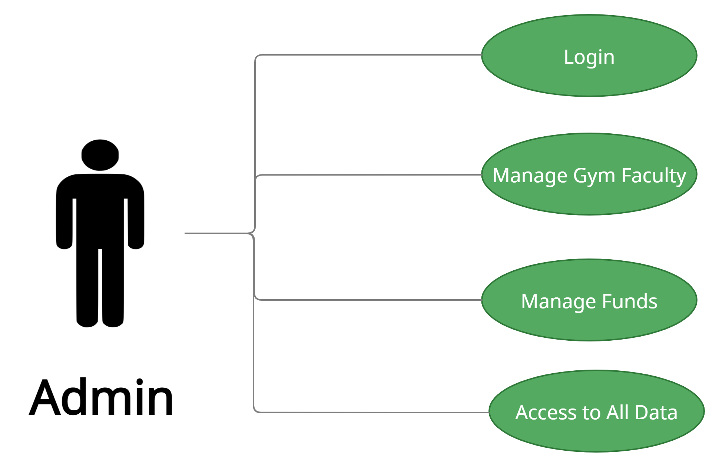

*Fig. Use case diagram for admin*

1. In Admin use case diagram Admin is the Actor.
2. Admin can handle following use cases:
3. Login
4. Manage Gym Faculty
5. Manage Funds
6. Access to All Data

**Customer:**

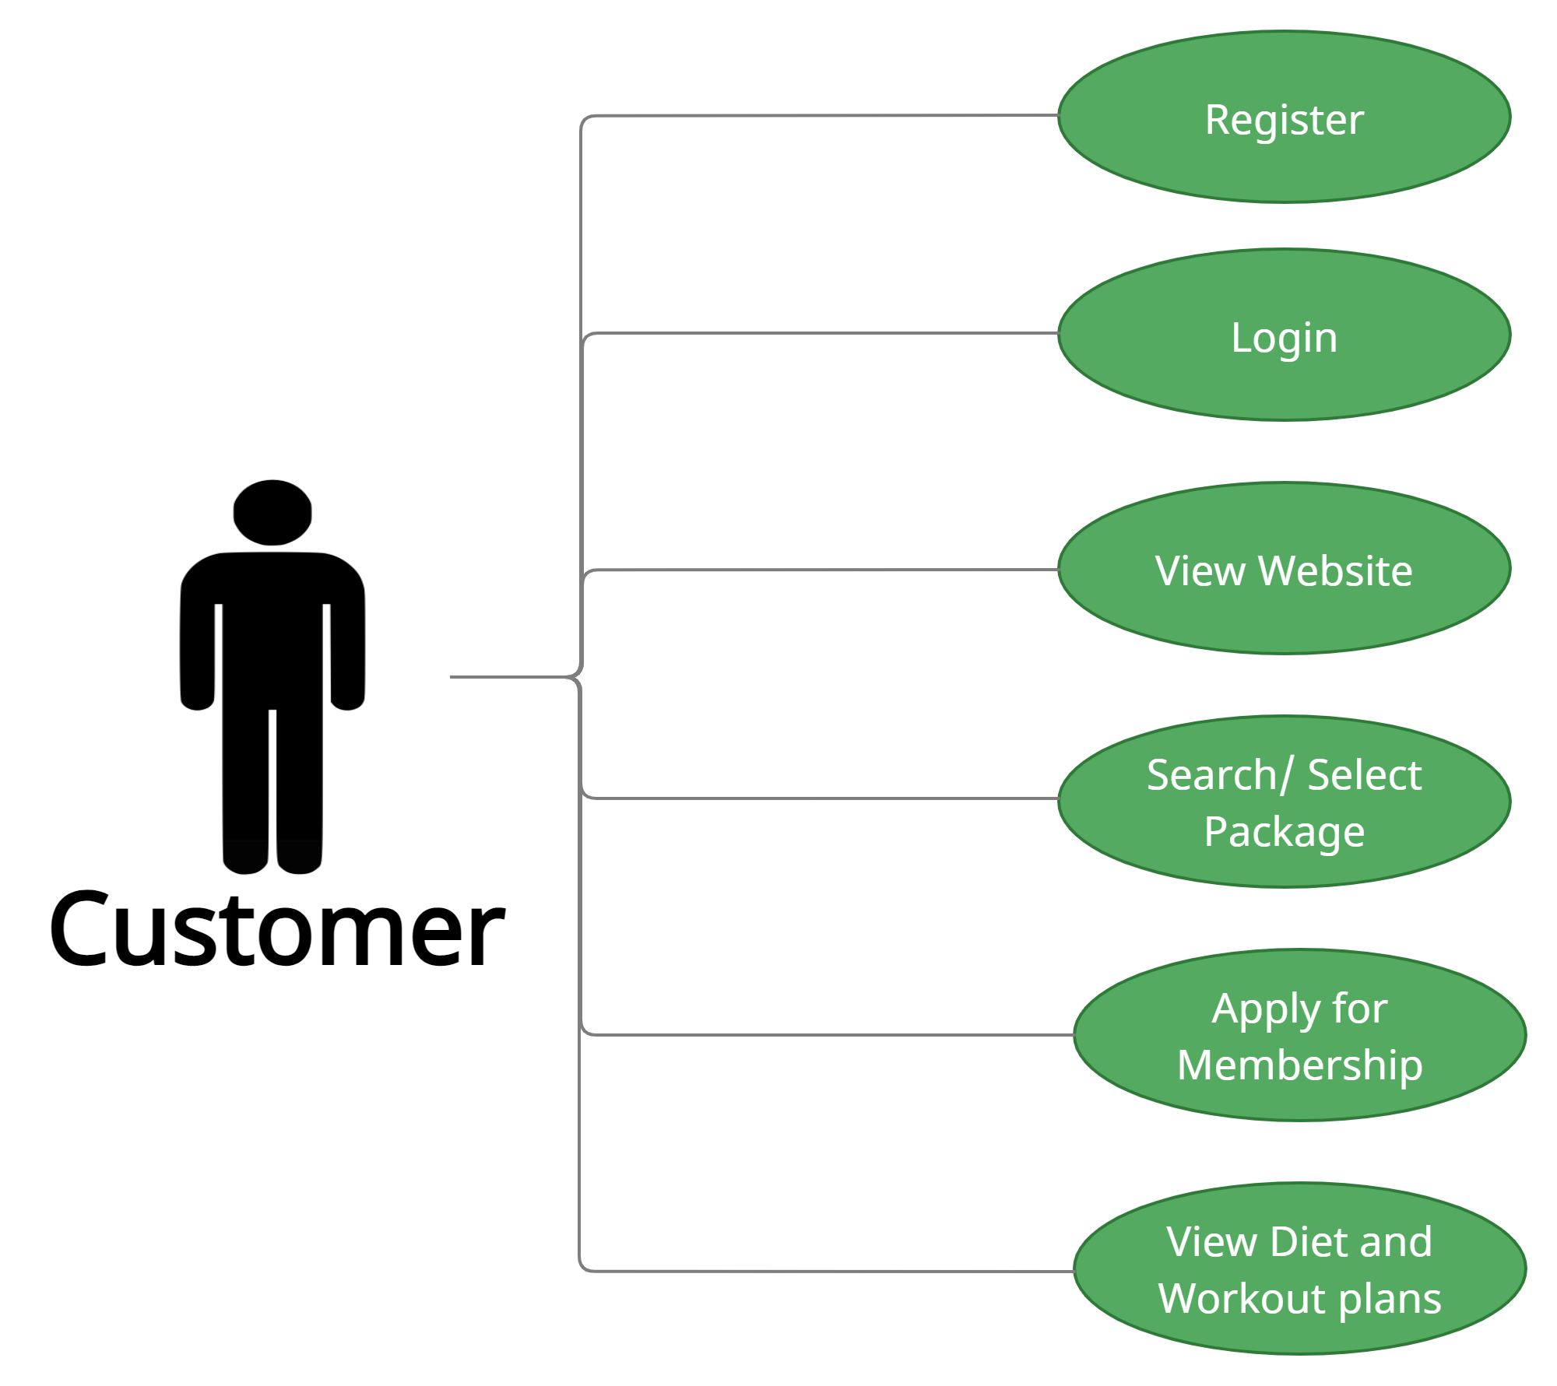

*Fig. Use case diagram for Customer*

1. In Customer use case diagram Customer is the Actor.
2. Customer can handle following use cases:
3. Register
4. Login
5. View Website
6. Search/Select Package
7. Apply for membership
8. View Diet and Workout Plans

**Trainer :**

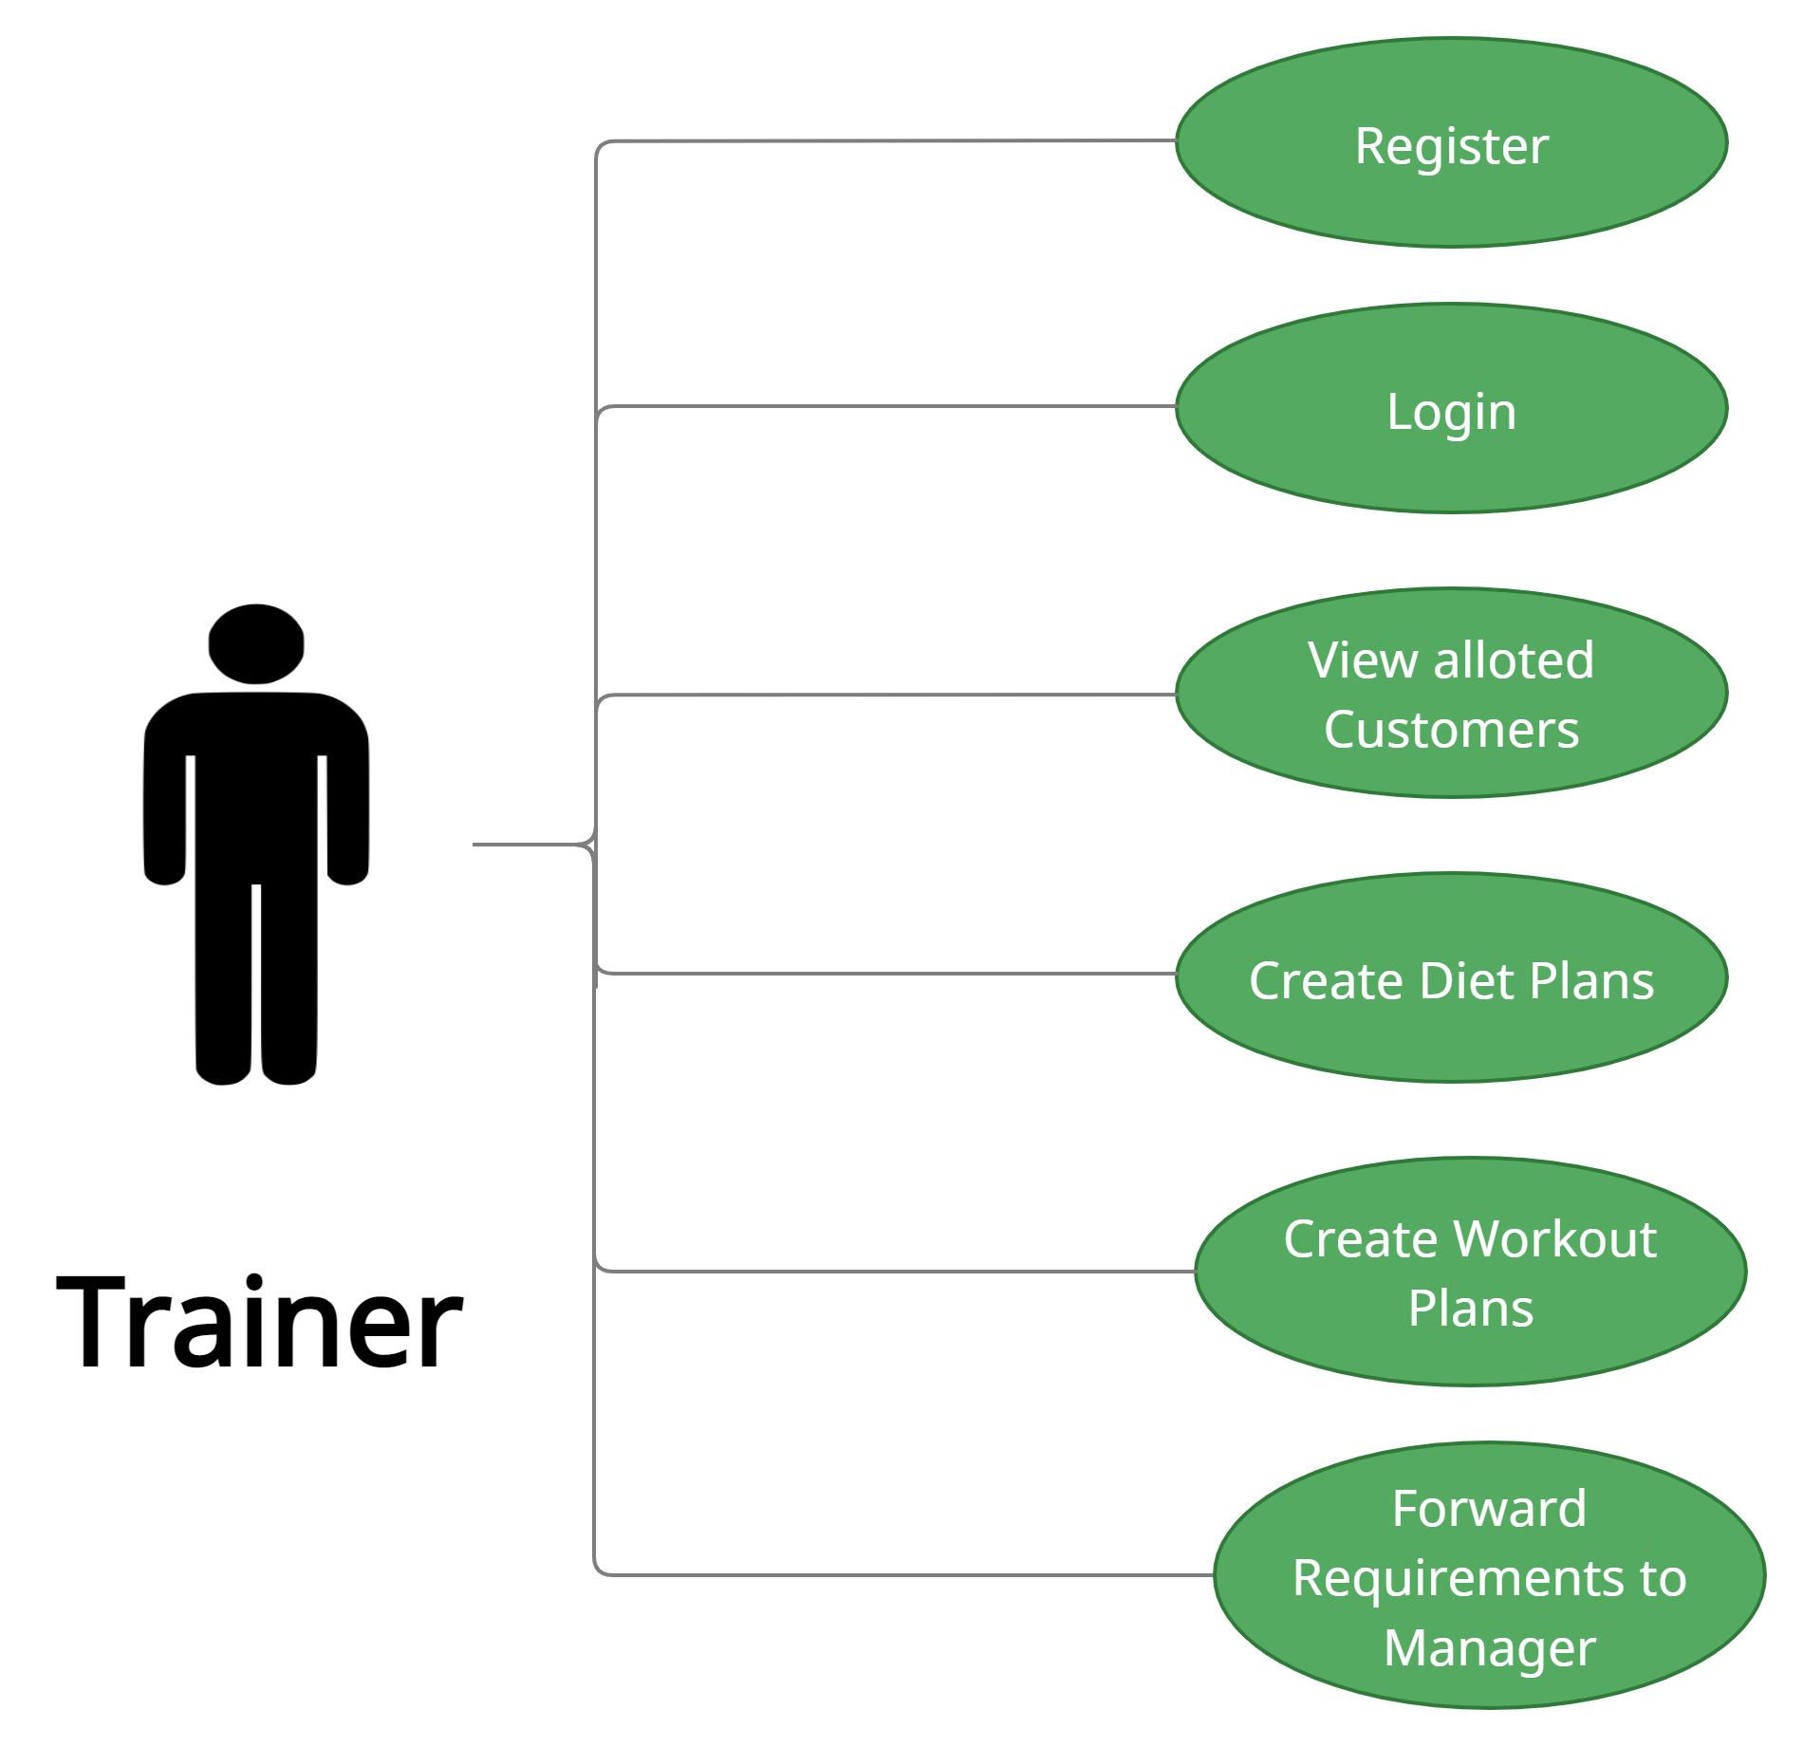

*Fig. Use case diagram for Trainer*

1. In Trainer use case diagram Trainer is the Actor**.**
2. Trainer can handle following use cases:
3. Register
4. Login
5. View Alloted Member
6. Create Diet and Workout Plans
7. Forward Requirements to manager

**Manager :**

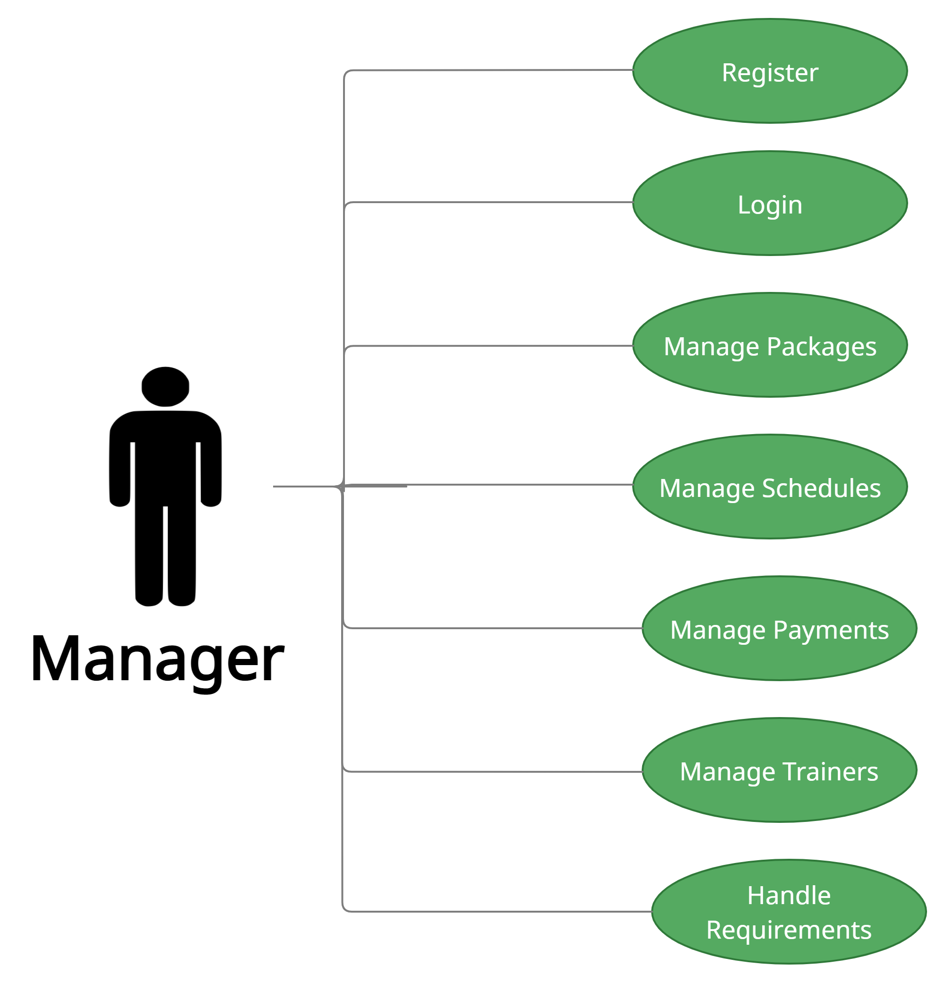

*Fig. Use case diagram for Manager*

1. In Manager use case diagram Manager is the Actor.

2. Manager can handle following use cases:

a. Register

b. Login

c. Manage Packages

d. Manage Schedules

e. Manage Payments

f. Manage Trainers

g. Handle Trainers